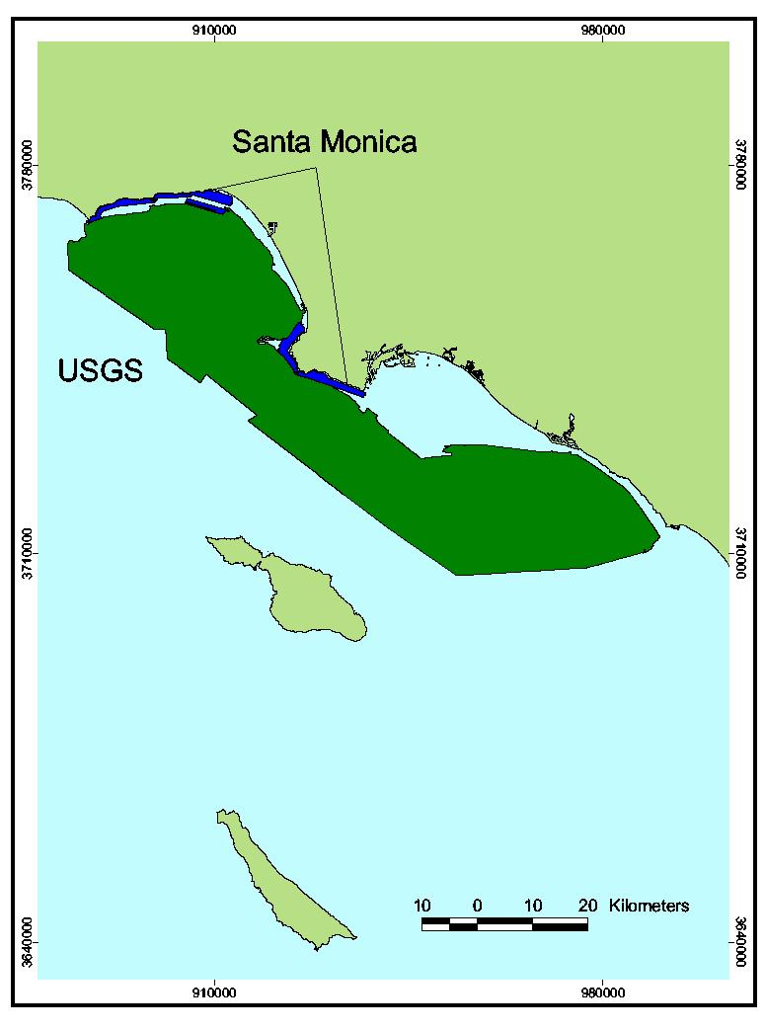
Footprint Map for Southern Region B. Regions included in this volume were either surveyed by CSUMB (Santa Monica (nearshore) – blue) or the USGS (Santa Monica (offshore) – green) using multibeam imagery and mapped by the Center for Habitat Studies.

